 |  | Marks (2 or 3)
1 | Explain the meaning of Traditional knowledge
Ans | Traditional knowledge or indigenous knowledge is developed by local indigenous communities that are well-developed and whose long-standing customs and practices are followed by these communities from generation to generation. Studies into the origins, behaviour, and development of humanism in both prehistoric and modern societies led to the recognition of traditional knowledge. The adoption of traditional knowledge by international organisations, like the UN, has resulted in its widespread appreciation and recognition | 02
2 | Explain any three threats to traditional knowledge | 03
Ans | Language threat: Indigenous languages and dialects preserve enormous amounts of traditional knowledge, such as Ayurveda in Sanskrit. These languages have been at the receiving end of colonial exploitation and modern lifestyles.  External pressures: The traditional methods of preserving or transmitting knowledge to future generations are also threatened by external pressures. These include migration, environmental pressures, the impact of modern lifestyles, disruption of traditional ways of life,and the impact of globalisation, etc.  Biopiracy: Biopiracy is the commercial exploitation of biochemicals or genetic materials that occur naturally.
3 | Explain the need to protect traditional knowledge | 03
Ans | Protecting Indigenous culture and identities: Traditional knowledge and languages are a significant way to maintain and preserve Indigenous cultures and identities and promote well-being.  Protecting livelihoods: Traditional knowledge is one of the sources of livelihood for indigenous people, which must be protected.  Health benefits: As traditional knowledge is connected with environment and spirituality, they are important to well-being. Further, traditional medicines can provide health benefits to a large population, like in India.
4 | List the different types of traditional knowledge | 03
Ans | 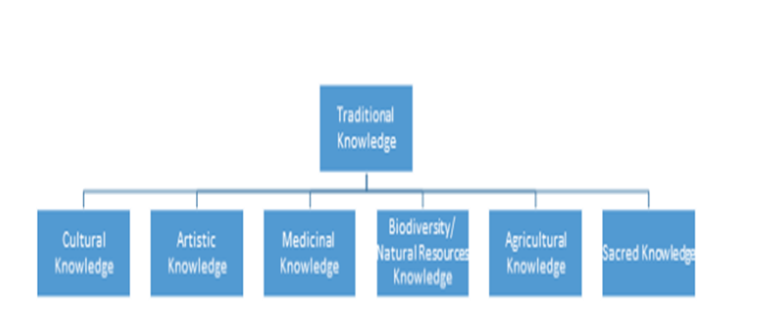
5
Ans
6
Ans
7
Ans
8
Ans
9
Ans
10
Ans
11
Ans
12
Ans
13
Ans
14
Ans
15
Ans
16
Ans
17
Ans
18
Ans
19
Ans
20
Ans
21
Ans
22
Ans
23
Ans
24
Ans
25
Ans
26
Ans
27
Ans
28
Ans
29
Ans
30
Ans
31
Ans
32
Ans
33
Ans
34
Ans
35
Ans
36
Ans
37
Ans
38
Ans
39
Ans
40
Ans
41
Ans
42
Ans
43
Ans
44
Ans
45
Ans
46
Ans
47
Ans
48
Ans
49
Ans
50
Ans
51
Ans
52
Ans
53
Ans
54
Ans
55
Ans
56
Ans
57
Ans
58
Ans
59
Ans
60
Ans
61
Ans
62
Ans
63
Ans
64
Ans
65
Ans
66
Ans
67
Ans
68
Ans
69
Ans
70
Ans
71
Ans
72
Ans
73
Ans
74
Ans
75
Ans
76
Ans
77
Ans
78
Ans
79
Ans
80
Ans
81
Ans
82
Ans
83
Ans
84
Ans
85
Ans
86
Ans
87
Ans
88
Ans
89
Ans
90
Ans
91
Ans
92
Ans
93
Ans
94
Ans
95
Ans
96
Ans
97
Ans
98
Ans
99
Ans
100
Ans

